Incident Management Site



|  |  |
| --- | --- |
| Page | Content |
| 2 | Table on Contents |
| 3 | Description |

**Description**

My site is broken down into 4 main pages.

* Login/Register (Same page, different function)
* Search Screen (Acts as a “home page”, connects all of the other pages)
* Ticket creation
* View screen (Used to view all of a user’s tickets, a single ticket and update statuses

The bottom 3 pages all require you to be logged into to view.

Everything in the header is a link. The active page is shown in white while other pages are grey. The red buttons (excluding log out) will change between pages.

C:\Users\Ryan_2\Desktop\ss (2013-04-22 at 11.20.39).png

Clicking a row in the table will allow you to view it and change its status. Changing any status to open clears the owner while setting any status to Pending/Finished makes you the owner. An owner is NOT required.

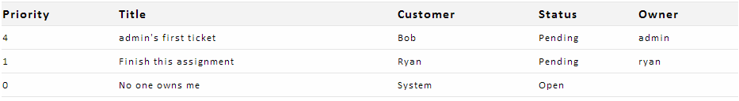

On the View screen you can see 1 or more collapsed tickets. In the header you will see the Title and priority to the right and the status to the left. Changes to the Status are made immediately. Clicking the header will Hide/Display the tickets. Only tickets with the pending status will display when you click “My Tickets” in the header, but they will not disappear until the page is refreshed to prevent accidently closing a ticket.  
